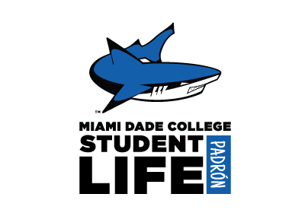

STUDENT LIFE TRAVEL PACKAGE
Padrón Campus

Club/Organization Name

Event/Travel
Date(s)

Location
Clubs & Organizations OR Conferences Funded by Student Life
Signature Pathway

__Student Life Director (Room 6018)
__ Dean of Faculty* (Room 1308)
*If chaperone reports to Academic Affairs i.e., Club Advisor
__Dean of Students (Room 1308)
__Senior Director of Campus Administration (Room 6153)
__Campus President (Room 6153)

*Please return completed packet to Student Life*
Please check once signed. Thank you.
Package Content
__Request for Leave of Absence and Reimbursement Form (P-2)
__Travel Advance and Expenses for Student Services Monies Form (T-form)
__Student Life Packet with Meal Money Form & Agreement for Off-Campus College Activity
__Attachments: Reservations (Lodging, Transportation), Agenda, Registration etc.

